* **SUNY Gen Ed Course**:

U.S. History and Civic Engagement

**HIS 107 Modern U.S. History**

An introduction to the history of the United States from 1900 to the present. A continuation of HIS 105 and 106. There are no prerequisites.

HIS 107 is a survey of the United States in the twentieth and twenty-first centuries, covering the major trends and movements in modern U.S. history.

**Topics**: This course covers examines the rise of the U.S. as a world power; the Progressive Era; the First World War; the “Roaring 20s”; the Great Depression and the New Deal; the Second World War; the Cold War; the Civil Rights Era and 1960s activism, the Vietnam War; the rise of Conservatism; the end of the Cold War and the start of the next phase of globalization; and the impact of September 11, 2001 and the vital question of America’s role in the changing modern world.

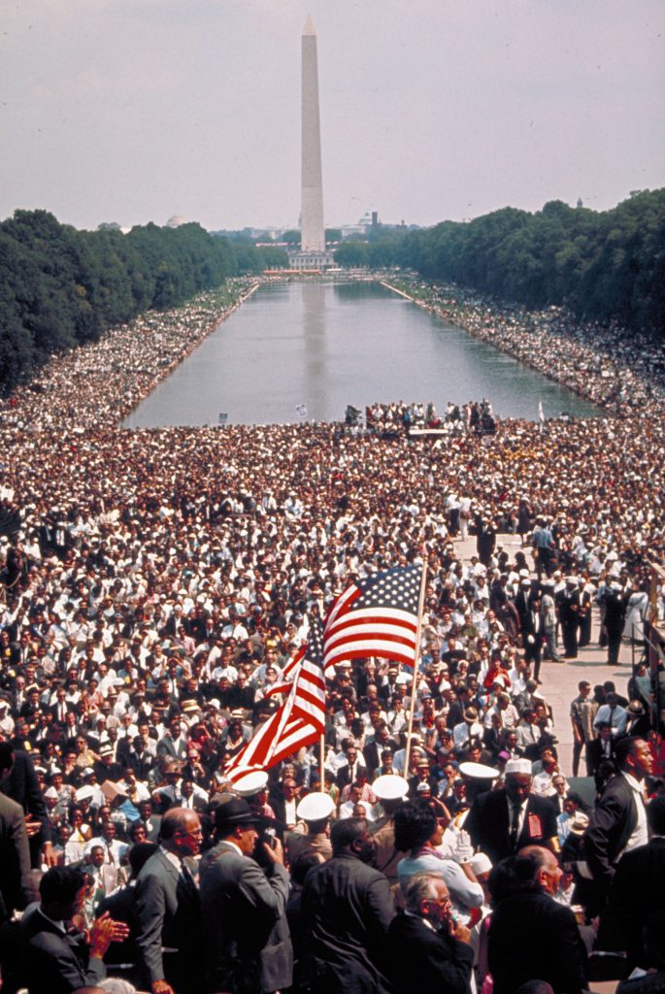

**Catalog Description:**

**Enduring Questions (EQ) sections of HIS 107**

**This section of HIS 107 has been designated an Enduring Questions (EQ) course.** One of the primary goals of the EQ designation is to demonstrate to participants that disciplines across the liberal arts are grappling with similar ideas.

The overall objective of this course is to help students to analyze the past and relate it to current problems and concerns while they develop a basic understanding of United States History from 1900 to the present day.

This course focuses on how U.S. history has dealt with questions about the human experience and the nature of:

**Justice  
Rights   
Liberties & Responsibilities  
Happiness  
Beauty/Love/Truth/Friendship**





