**SUNY Gen Ed Categories**:   
 Humanities  
 Social Sciences  
 Diversity and Global Awareness

**ANT 152: Cultural Anthropology**

**Enduring Questions (EQ) sections of ANT 152**

**Catalog Description:**

This course provides students with an introduction to the cultural and social systems that humans have devised over time and space, using a comparative anthropological perspective. The course will also focus on using the methods, theories, and concepts of cultural anthropology to understand and explain the cultural diversity seen around the world.

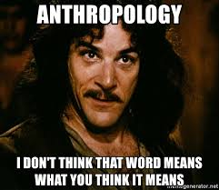

 In addition to being an Honors section, this course has also been designated an **Enduring Questions (EQ)** course.  EQ course sections at OCC are offered in various disciplines in the liberal arts.  One of the primary goals of the EQ designation is to demonstrate to participants that disciplines across the liberal arts are grappling with similar ideas—challenging ideas that have been the subject of analysis throughout the history of human civilization.

*

* This course and other EQ sections explicitly confront fundamentally important questions about things like justice, equality, happiness, freedom, and friendship.  Throughout the semester, we will utilize readings from a list of primary source texts that have stood the test of time and reveal the complexity of the human condition.
* EQ courses do not require additional reading or work.  Instead, these courses aim to help you form the habit of posing and grappling with “big questions” while developing the skill of close reading.
* You will also have the opportunity to participate in conversations about a variety of ideas that are central to understanding the human experience.  Welcome to this Enduring Questions course!