* **SUNY Gen Ed course**:

Basic Communications - Written category

**ENG 103 Freshman Composition and Literature I**

**This section of ENG 103 has been designated an Enduring Questions (EQ) course.** One of the primary goals of the EQ designation is to demonstrate to participants that disciplines across the liberal arts are grappling with similar ideas.

While you learn skills necessary for writing and revising college-level academic writing, you will also read the works of many great thinkers and join their conversation by considering the questions all humans ask of life through class discussion and writing.

**Enduring Questions (EQ) sections of ENG 103**

**Catalog Description:**

Emphasizing the recursive nature of writing and the process of revision, this course teaches students the skills and processes necessary for writing and revising college-level academic prose. Various aspects of writing, including invention/pre-writing, composing, revision, and editing/proofreading will be taught. Critical readings of various non-fiction texts may be used to develop understanding of rhetorical conventions and genres. Composing in and for electronic environments, as well as their conventions, will also be taught.

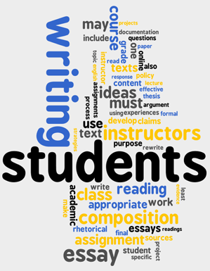

Various aspects of writing, including invention/pre-writing, composing, revision, editing, proofreading, composing in and for electronic environments and their conventions will be taught. You will read non-fiction texts that ask and attempt to answer real life enduring questions that affect all of us every day.

|  |  |
| --- | --- |
| **Major Topics** Knowledge/Perspective,  Happiness, The Nature of Justice, Rights,  Responsibilities, Liberties,  Love, Beauty, Friendship and Truth | Here is a sample of just some of the questions you may be discussing and writing about in class:   * How does my perspective differ from those around me? * How does knowledge and education change my life or the lives of others? * Is justice for all really possible? What do we need to change to make it possible? * What responsibilities do we each have to ourselves? Our family? Community? Country? Globally? * What makes us happy? How important is happiness? * What does it mean to love someone? What impact does love have on our lives? * What is beautiful? Is beauty a necessity of life? What affect does beauty have on us? |

