* **SUNY Gen Ed course** Humanities

**PHI 108 Ethics**

We all want to do the right thing (right?). But figuring out what that is can be a challenge. In this course, while you might not walk away with simple, pat answers to difficult moral questions, you will acquire more tools to think about ethical issues. And you’ll learn what lots of smart people in the past have contributed to this conversation.

And to really get a handle on these topics it is a good idea to look at the kinds of answers proposed by super-smart thinkers from different times and places. And this is exactly what you will get the chance do in and **Enduring Questions (EQ)** section of PHI 108!

PHI 108 is an introduction to basic problems about the application of the concepts of **right, wrong, good, and bad**, to persons and their actions.

**Enduring Questions (EQ) sections of PHI 108**

**Catalog Description:**

An introduction to basic problems about the application of the concepts of right, wrong, good and bad to persons and their actions. Topics covered may include major ethical traditions, relativism and absolutism, morality and religion, and the foundations of moral obligation.

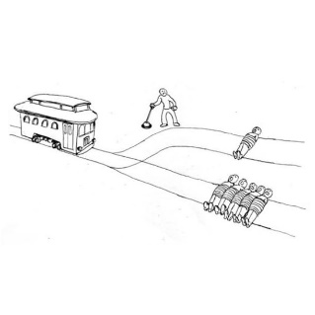

An EQ section of PHI 101 is not harder than other sections. The difference is in the approach: in an EQ section, you will read many ***enduring texts***, i.e., texts that have spoken on ***enduring questions*** to many different kinds of people in many different historical and cultural circumstances. Through critical reading and thinking – and some in-class discussions – you will discover how these texts can help you navigate your life in the 21st century.

|  |  |  |
| --- | --- | --- |
| Topics covered include:   * Major ethical traditions * Relativism and absolutism * Morality and religion * The foundations of moral obligation | Questions considered include:   * Aren’t “right” and “wrong” just concepts made up by people and their cultures? * Doesn’t morality come from God? * Isn’t morality just a matter of taste or preference? * Do I have moral obligations to help others, or should I just look after myself? |  |

And, yes, there will be trolleys!!

